

SCHOOL OF COMPUTER SCIENCE AND ENGINEERING
Lab Assignment - IV, Winter Semester 2020-21
Course Code : CSE2011 Course Name: Data Structures and Algorithms

Last Date : 17-06-21 Slots : L23 +L24 and L51+L52

Marks : 10

Note:
Upload the codes along with the snapshots of the output for each.

1. Construct the given graph using Adjacency Matrix and Perform breadth first search on it.

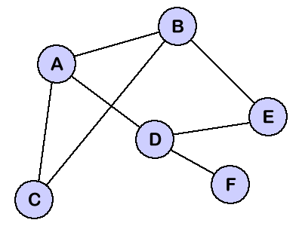

2. Write a program to implement Kruskal’s Algorithm and find the Minimum Spanning Tree for the following graph.
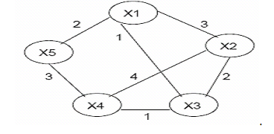
3. Write a program to implement Prim’s Algorithm and find the Minimum Spanning Tree for the following graph.

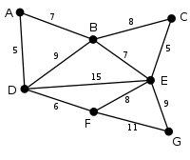
4. Write a program that creates the following graph and finds the shortest path from the vertex O to all the other vertices using Dijikstra’s Algorithm.

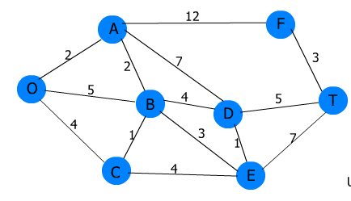

5. Given an array of elements, construct a min Heap and perform in-place sorting
(ascending order) using heap sort.

